Closure

Diversion

Barkway Remembrance Day Parade

TEMPORARY TRAFFIC REGULATION ORDER



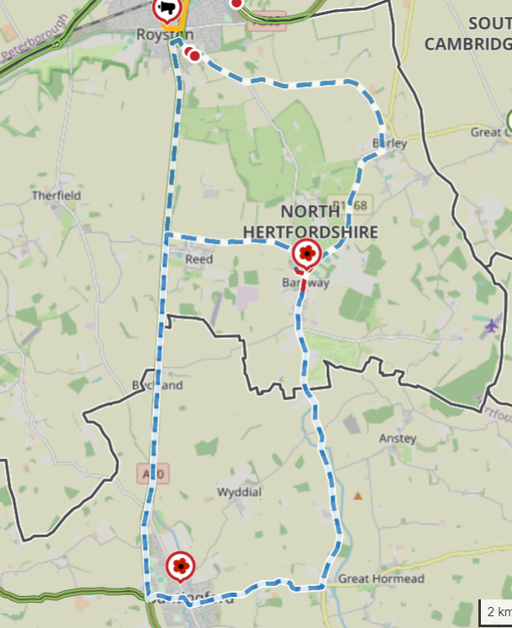
© Crown copyright and database rights 2023 OS EUL 100019606. You are permitted to use this data solely to enable you to respond to, or interact with, the organisation that provided you with the data. You are not permitted to copy, sub-license, distribute or sell any of this data to third parties in any form.

B1368 Cambridge Road
B1368 High Street
Royston Road

